Power market / Imbalance statement in Czech Republic

This report focuses on the time series of the system imbalance in 2021, it presents the analysis of the series and the prediction.

1. Analysis of the series

Hourly system imbalance in 2021 was presented in figure 1. A down trend from the beginning to the end of the year was observed. To verify this down trend, the daily and weekly system imbalance were calculated by sum of 24 hours imbalance and 7 days imbalance, respectively. According to daily and weekly system imbalance presented in figure 2 and 3, the down trend was confirmed. Importantly, the down trend was significantly observed after July 2021. This down trend is caused by one of two reasons or both reasons below:

1. Energy production in Czech Republic tended to decrease during 2021
2. Energy consumption in Czech Republic tended to increase during 2021

According to Enerdata.net (<https://www.enerdata.net/publications/daily-energy-news/cezs-power-generation-declined-8-2021-czech-republic.html>), Czechia power generation declined by 8% in 2021. Due to Covid-19, Czech Republic was locked down almost the first haft of 2021. The lockdown was ended on July 1st. Therefore, Czech Republic consumed more energy in the second haft 2021 than in the first haft. That resulted the meaningly down trend of system imbalance after July (figure 4). It’s interesting to verify the down trend in the years without Covid-19 (2020, 2019 …)

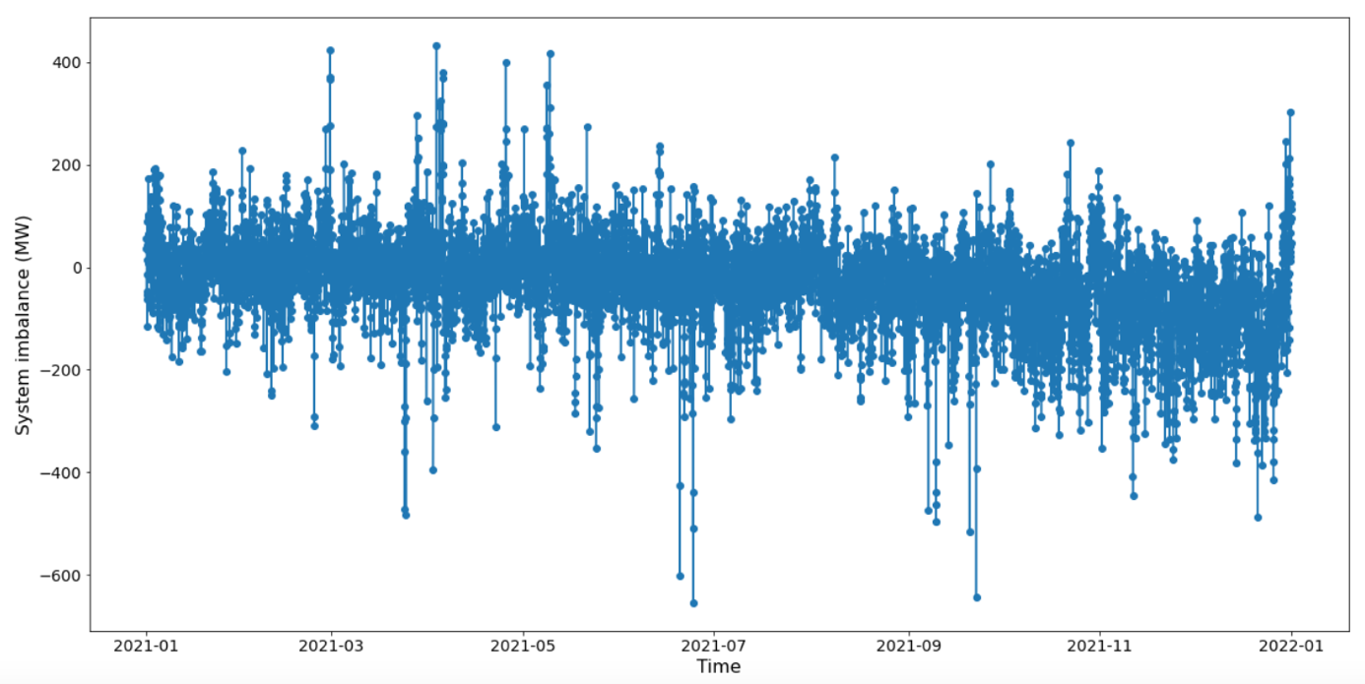

Figure 1: Hourly system imbalance in 2021

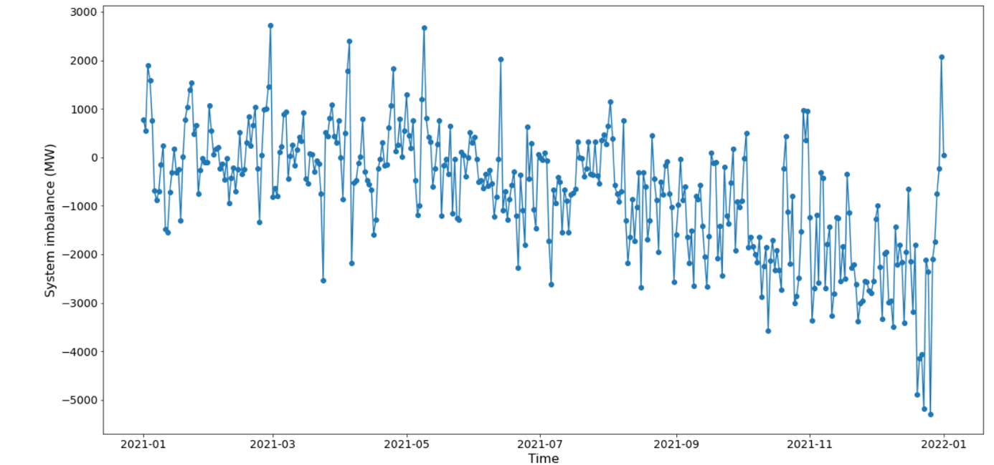

Figure 2: Daily system imbalance in 2021

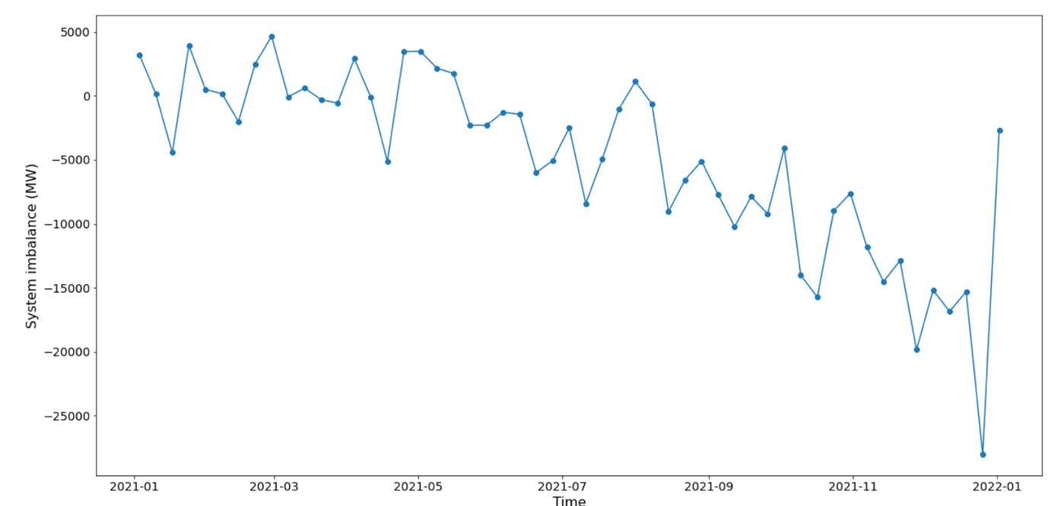

Figure 3: Weekly system imbalance in 2021

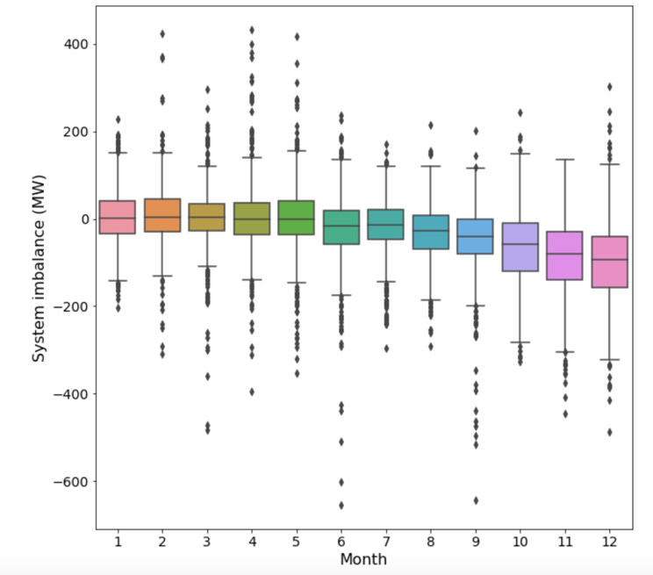

Figure 4: Boxplot of system imbalance by month

It’s difficult to determine seasonality component in hourly system imbalance. However, a short-term seasonality (4-5 days patterns) was observed in daily system imbalance (figure 5). This pattern was probably due to energy consumption higher on working days than on weekend days. That hypothesis was confirmed by boxplot of system imbalance by day of week (figure 6), which revealed an uptrend from Monday to Sunday.

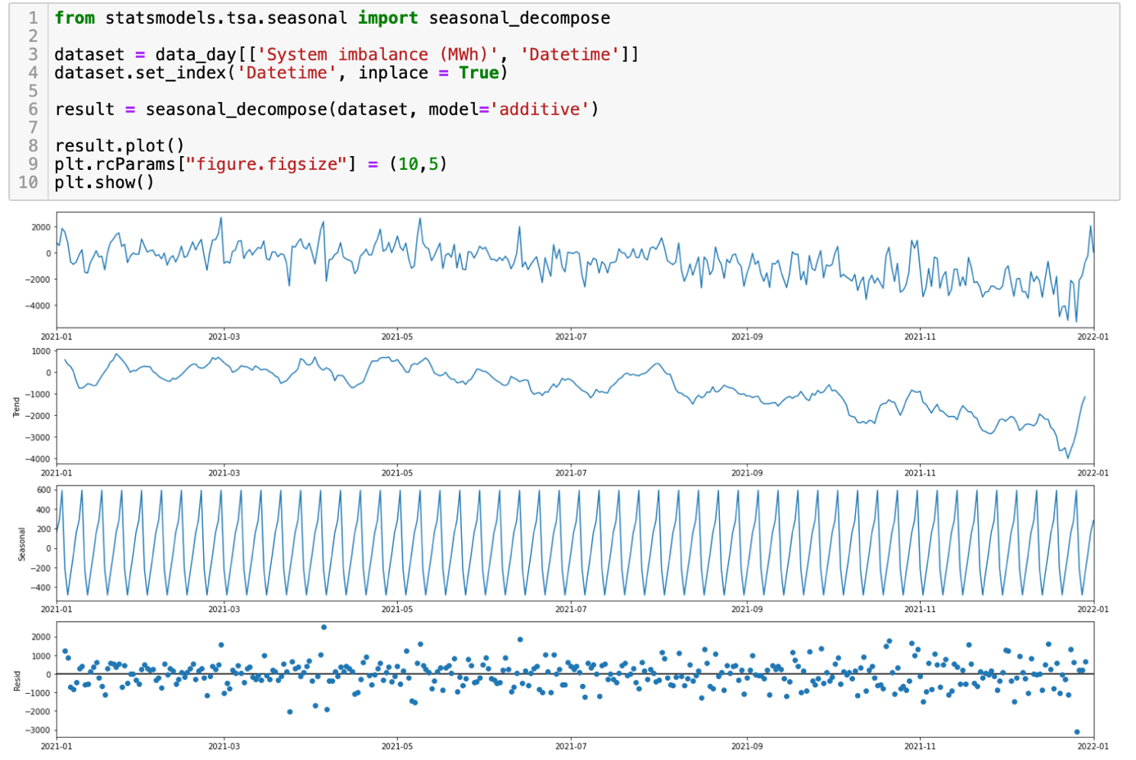

Figure 5: Decomposition of system imbalance time series into trend and seasonality.

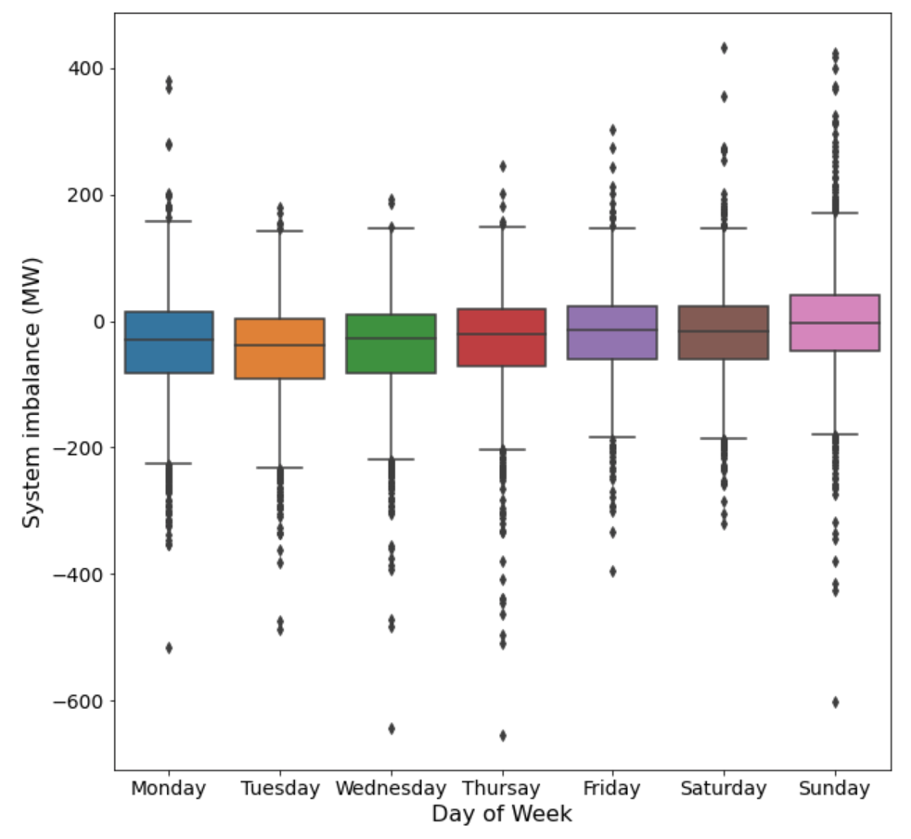

Figure 6: Boxplot of system imbalance by day of week.

1. Prediction
   1. System imbalance forecasting

This time series can be used for day-ahead and intraday forecasting of system imbalance (MW) in Czech Republic. The Long Short-Term Memory (LSTM) networks was used in this forecasting. LSTM is an artificial recurrent neural network used in deep learning and can process entire sequences of data. Due to the LSTM’s ability to learn long term sequences of observations, the system imbalance at the current time (t) as well as the 24 prior hours (t-1, t-2, …, t-24) were used as input variables to predict the system imbalance at the next time (t +1). Moreover, The LSTM is capable of capturing the patterns of both long-term seasonality such as a yearly pattern and short-term seasonality such as weekly patterns.

90% of dataset were used to train the LSTM model. The prediction was evaluated by Mean Absolute Error (MAE) of 51 (MW) and presented by figure 5. This LSTM forecasting is more reliable than Moving Average of 24 hours forecasting (MAE = 63)

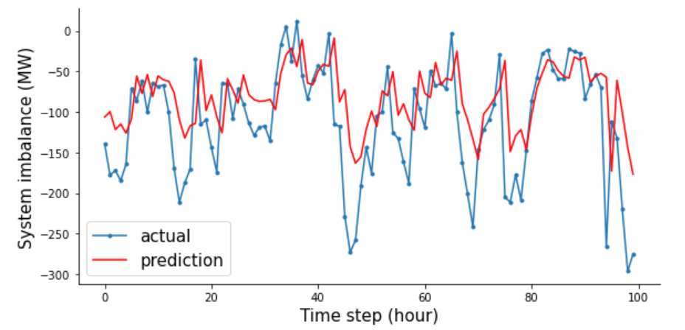

Figure 7: Prediction using LSMT model.

* 1. Long-Short forecasting

The system imbalance time series was transformed into a Long-Short time series. If the system imbalance is positive or the country is Long, LongShort value is equal to 1. If system imbalance is negative or country is Short, LongShort value is equal to 0 (figure 8).

Figure 8: Long-Short time series.

Based on the Long-Short time series, we can predict the long or short status of the next hour (t+1). In this forecasting, we developed LSMT model for time series classification and the Long -Short status at the current time and the 24h before as input variables. The accuracy of the Long-Short forecasting using LSMT is 92%.

There is nothing special about the network structure or chosen hyperparameters, they are just a starting point for this problem. So, if I have more time, I will focus on the optimization of the LSMT network structure and hyperparameters.

|  |  |
| --- | --- |
| 1. Conclusions  * This analysis and forecasting were realized in one day * Energy consumption in Czech tended to increase in the last months of year 2021 due to end of lockdown * Czech consumed more energy on working days than on weekend days * LSMT forecasting is better than Moving Averge * LSMT classification with 92 % accuracy allow us to predict the Long or Short status in Czech with high reliable | 1. Perspectives  * We should check this trend in other years before Covid-19 * We should check in other years * We should optimize the LSMT network structure and hyperparameters to have a better forecasting * We should run A/B testing to check the benefit of LSMT forecasting and classification. |